ALL-IN-ONE-CONVERTER
PYTHON PROJECT

VITyarthi PROJECT

NAME:DIVYA PAL
REG NO.:25BAI10788

1.Introduction
The ALL-IN-ONE-CONVERTER is a Python-based console application designed to provide users with a versatile tool for converting units across several domains, including length, mass, temperature, time, currency, and numerical bases. Its menu-driven approach offers a smooth and intuitive user experience for everyday and educational conversions.

2. Problem Statement
The abundance of single-purpose conversion tools leaves users switching between applications for different units. This project solves the problem by incorporating multiple converters into one easy-to-navigate interface, increasing convenience and efficiency.

3. Functional Requirements
- Convert length between meters and kilometers
- Convert temperature between Celsius and Fahrenheit
- Convert mass between kilograms and grams
- Convert duration between hours and minutes
- Convert currency between INR and USD (using fixed rates)
- Convert numbers between binary, octal, decimal, and hexadecimal
- Robust input validation and error handling

4. Non- functional Requirements
- Fast execution and immediate response
- Modular, maintainable code
- Clear prompts and console outputs
- Compatibility across platforms
- Minimal resource consumption

5. System Architecture
The program is designed as a linear, menu-driven command-line application. Individual conversion functions are called from a main loop that handles user navigation. No persistent storage is used.

6. Design Diagrams
- Use Case Diagram:
User interacts with the All-in-One-Converter to select conversion types and input data, receiving results.
- Workflow Diagram:
Start → Show Main Menu → Get User Choice → Call Conversion Function → Input Values → Output Result → Repeat/Exit
- Sequence Diagram:
User → Main Menu → Converter Function → Input → Calculation → Result → Main Menu/Exit
- Class/Component Diagram:
Components: Main Menu, LengthConverter, TempConverter, MassConverter, DurationConverter, CurrencyConverter, BaseConverter
- ER Diagram:
Not applicable (no storage used)

7. Design Decisions & Rationale
- Seperation of logic into dedicated functions for readability and maintenance
- Linear menu design for ease of navigation
- Fixed currency rates to avoid network/API dependencies for demo
- Extensive input validation for reliability and user experience

8. Implementation Details
- Functions defined for each conversion type
- Main loop presents user menu and calls relevant function
- User input via console, conversion performed, results displayed
- Example:
def length_unit_converter():
# ... function logic ...
- Currency rates stored as constants

9. Screenshots / Results
Screenshot 1:
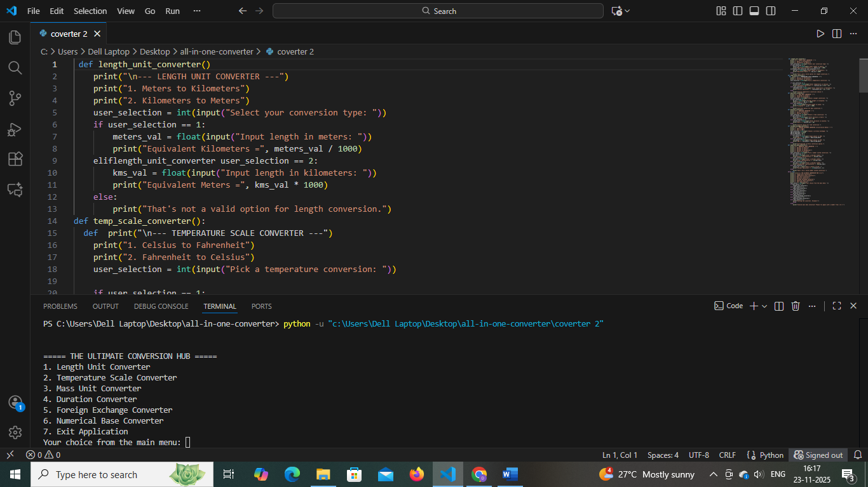
Screenshot 2:
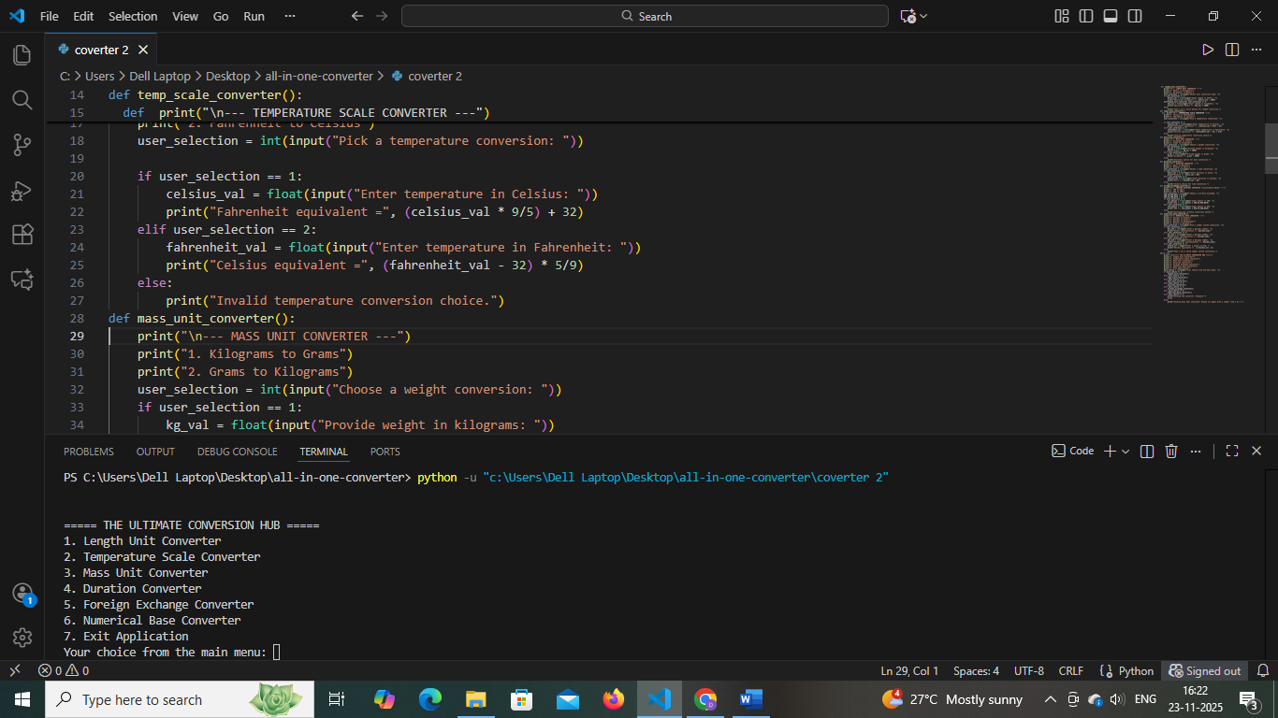
Screenshot 3:
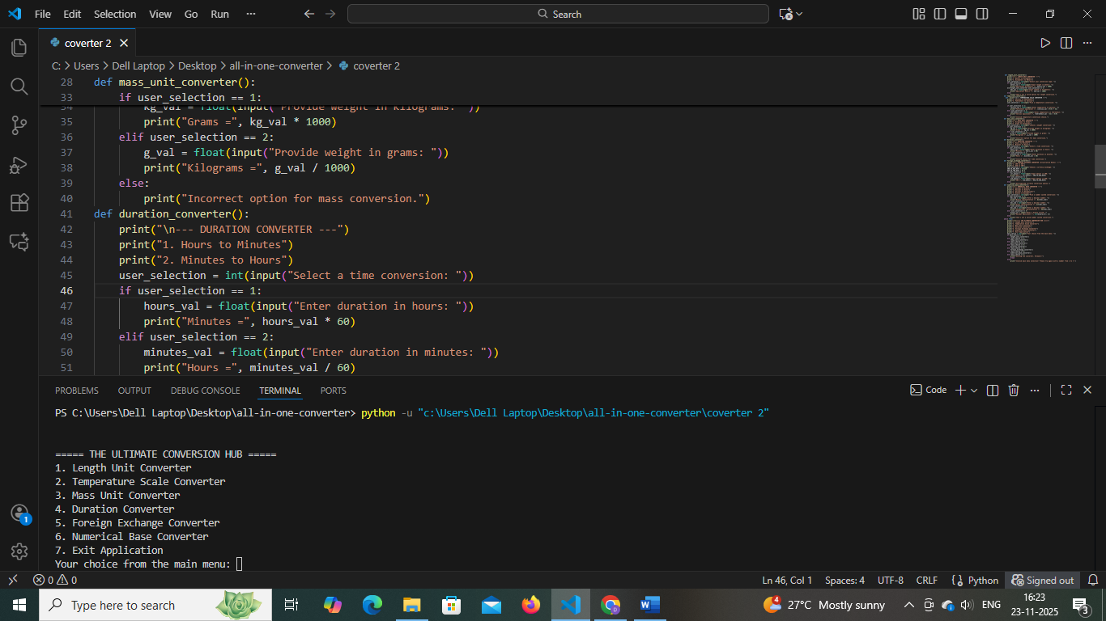
Screenshot 4:
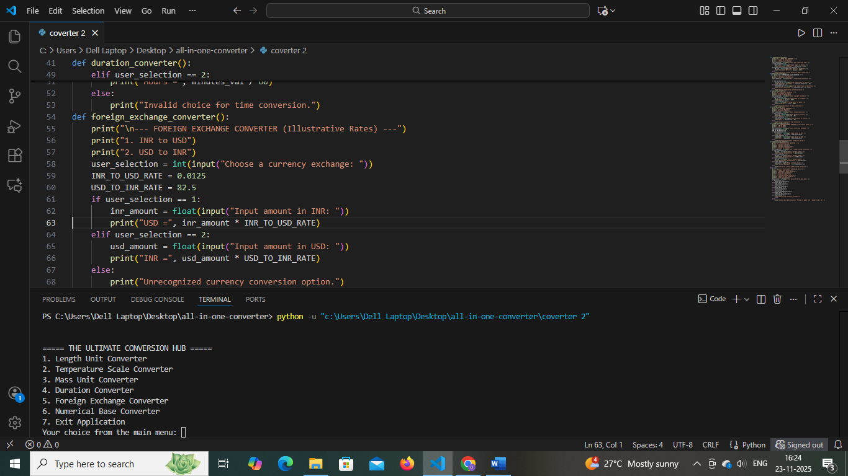
Screenshot 5:
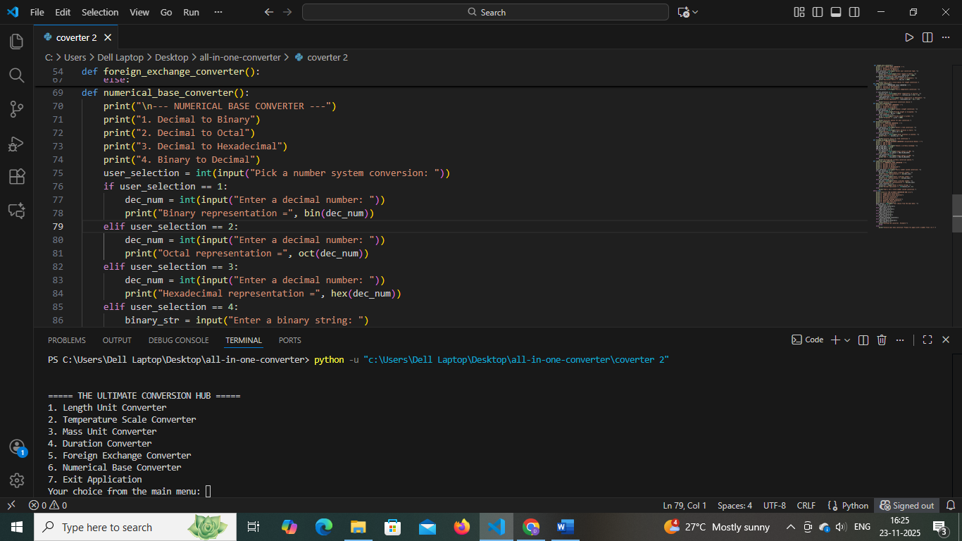
Screenshot 6:
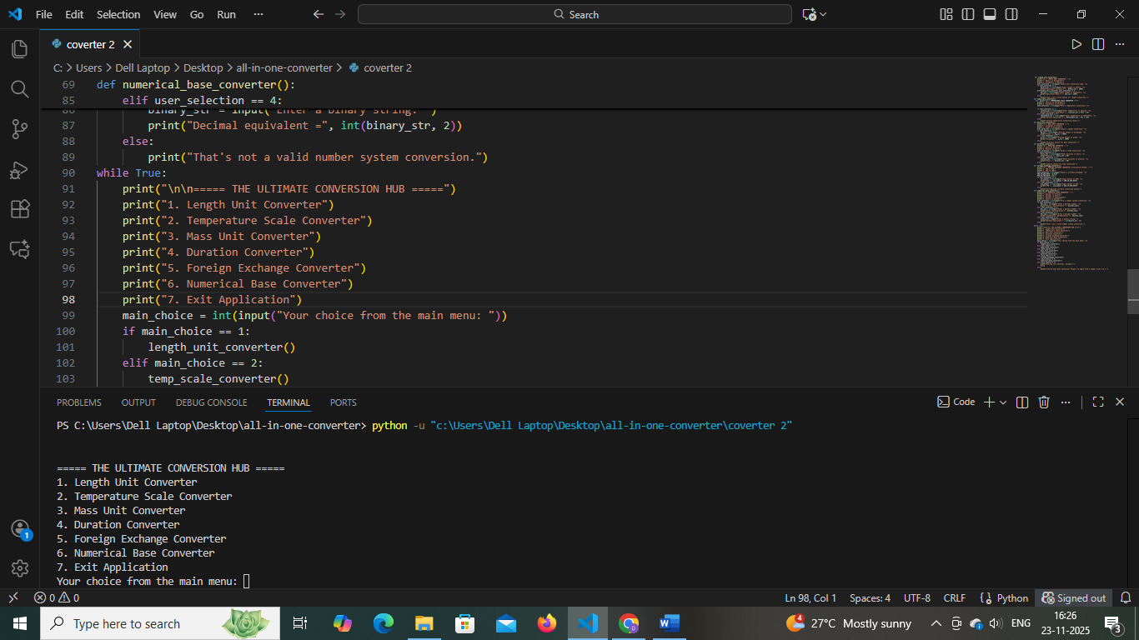
Screenshot 7:
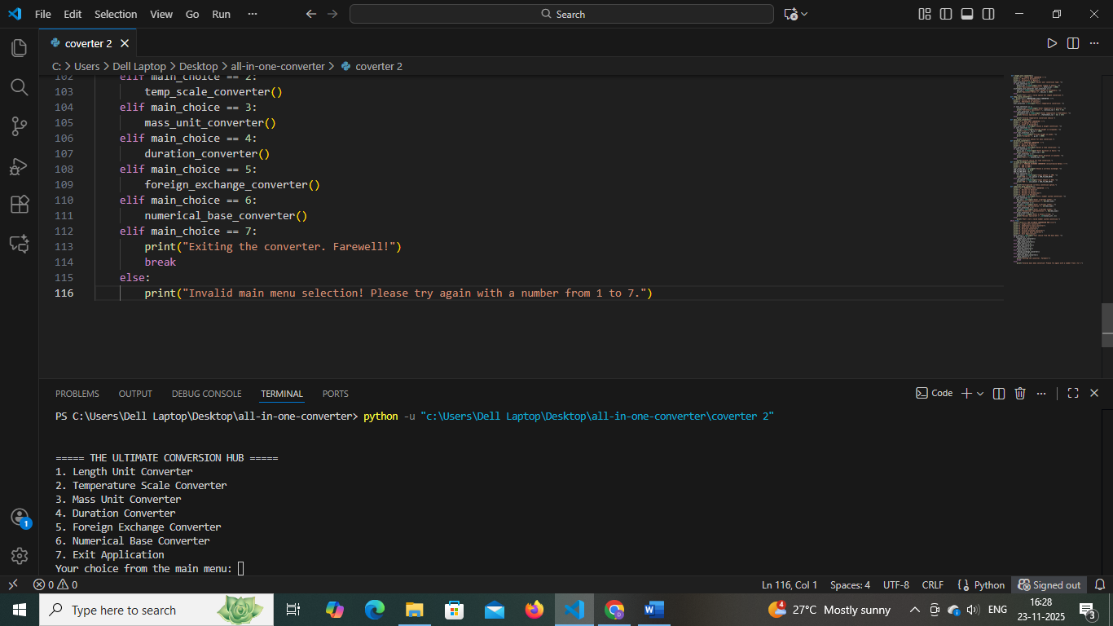
OUTPUT
https://youtu.be/r8DxZiiPKDI?si=0-Go21zFjaUMSpal
10. Testing Approach
- Manual test for each function: valid/invalid inputs
- Edge case testing for zero/negative values
- Output verification for each conversion type
11. Challenges Faced
- Comprehensive input validation
- Covering diverse conversion types in one application
- Streamlining user interface for clarity
12. Learnings & Key Takeaways
- Modular architecture aids scalability and maintenance
- Clear documentation increases usability
- Input checking is essential for preventing errors and ensuring user trust

13. Future Enhancements
- Add persistent storage for history
- Integrate real-time exchange rates via API
- Add volume, speed, and additional conversions
- Develop a graphical user interface
- Implement automated testing framework
14. References
- Swimm Documentation: Python Best Practices
- Docuwriter Python Documentation Guide
- Dagster Blog: Structuring Python Projects
- PEP 8 – Style Guide for Python Code
- Real Python: Documenting Python Code

